

The University of Azad Jammu and Kashmir, Muzaffarabad

Name Kamal Ali Akmal
Course Name | Software Designs and Architectures
Submitted to | Engr. Daniyal Nazir
Semester | 3rd
Session | 2024-2028
Roll No | 2024-SE-38
Lab No | 11
Submission date | 2 February 2026

Lab Task 11: Chat Application Design
Scenario Overview
A Chat Application allows multiple clients to communicate with each other through a central server. Clients send messages to the server, and the server receives, processes, and broadcasts those messages to all connected clients.
___________________________________________________________________________
Task 1: Client-Side and Server-Side Responsibilities

Client-Side Responsibilities
The client side is responsible for all user-related interactions.
Responsibilities:
- Display chat interface to the user
- Allow users to type and send messages
- Send messages to the server
- Receive messages from the server
- Display received messages in real time
Examples:
- Mobile app
- Desktop application
- Web chat client

Server-Side Responsibilities
The server acts as the central controller of the chat system.
Responsibilities:
- Accept connections from multiple clients
- Receive messages from clients
- Process messages (timestamp, sender info, validation)
- Broadcast messages to all connected clients
- Manage client connections and disconnections
- Ensure message delivery
___________________________________________________________________________
Task 2: UML Deployment Diagram
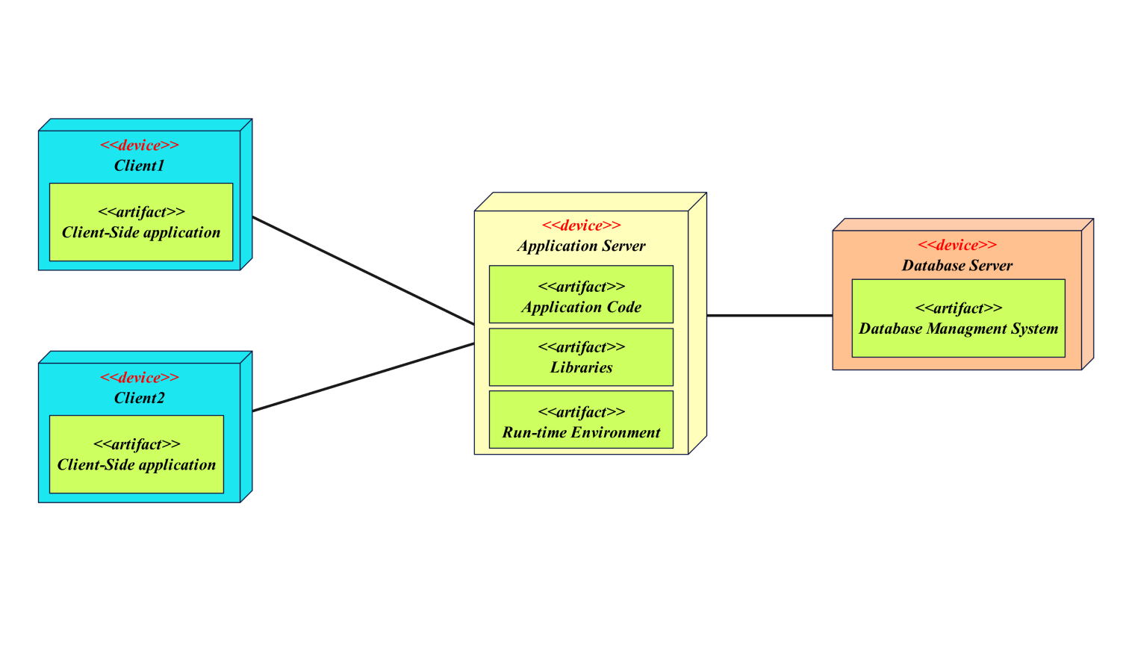
The UML Deployment Diagram shows the physical structure of the chat system. Multiple client devices are connected to a central server over a network. Each client runs a chat application, while the server hosts the chat server application.

What to Draw (Deployment Diagram)
Nodes
- Client Device 1 (Chat Client)
- Client Device 2 (Chat Client)
- Chat Server
Connections
- All clients connected to the server via Internet / Network
___________________________________________________________________________
Task 3: UML Sequence Diagram (Message Sending)
Scenario: Client sends a message
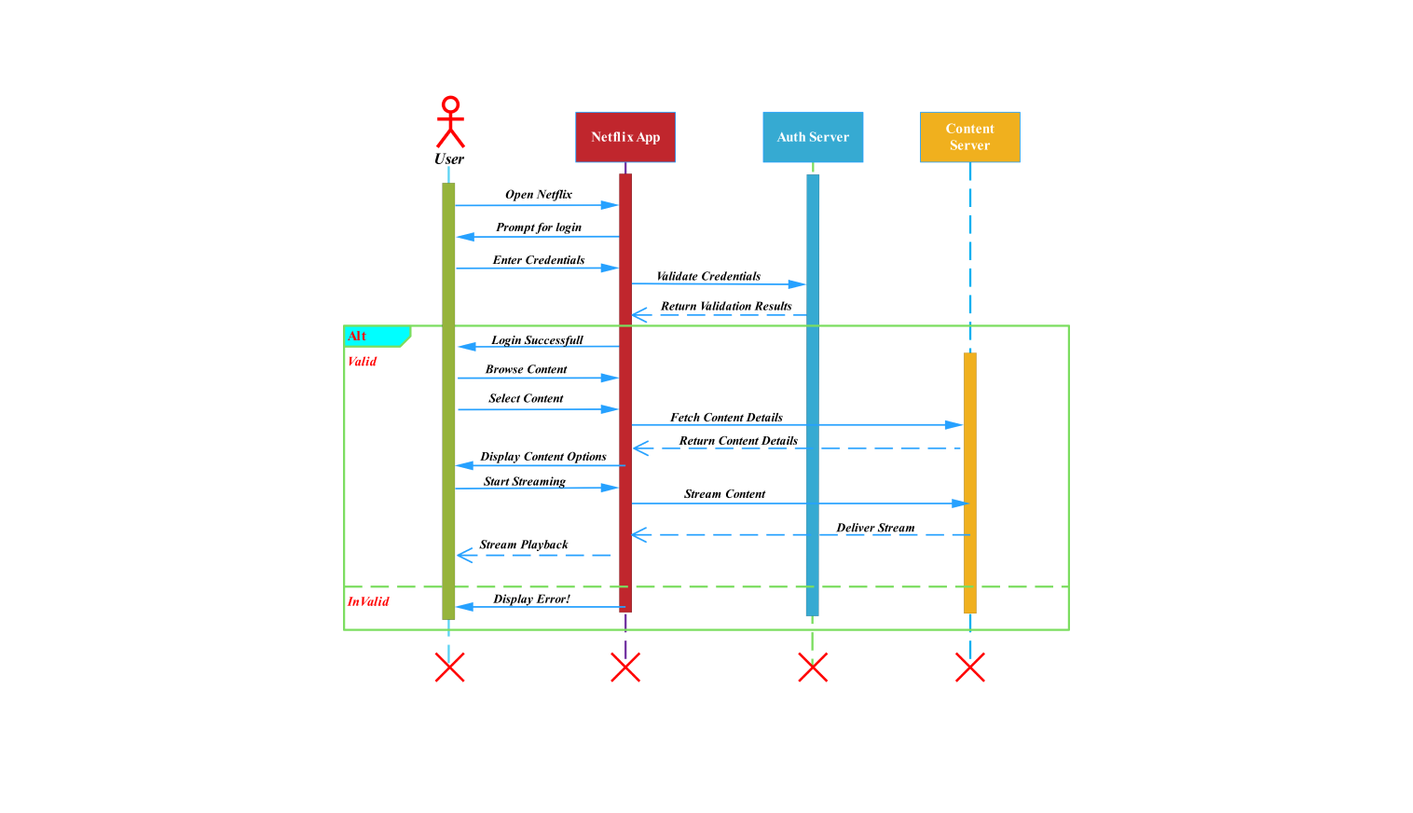
Draw in Tool
- Use lifelines for:
  - Client
  - Server
  - Other Clients
- Use arrows to show message flow
___________________________________________________________________________

Task 4: How the Server Manages Multiple Clients
The server manages multiple clients using a concurrent communication mechanism. Each client is assigned a separate connection, which allows the server to handle multiple users simultaneously.
Server Management Techniques
- Maintains a list of connected clients
- Uses:
  - Multi-threading OR
  - Asynchronous I/O
- Listens continuously for incoming messages
- Sends messages to all active clients
- Removes clients when they disconnect
This approach ensures real-time communication and efficient handling of multiple users.
___________________________________________________________________________
Conclusion
In this lab task, a chat application was designed using a client-server architecture. Client-side and server-side responsibilities were clearly identified. UML deployment and sequence diagrams were used to represent system structure and message flow. The server efficiently manages multiple clients to enable real-time chat communication.

